CHE327: Project-1 Report on

**“Life Cycle Prediction of Corrosion-Resistant Coatings of Offshore Pipeline Using Machine Learning”**

In Partial Fulfilment of the requirements for the degree of

**Bachelor of Technology**

In

**Chemical Engineering**

**Submitted by:**

|  |  |
| --- | --- |
| ANKITA RAI | 2211701110 |
| MANSI SINGH | 2211701121 |
| MANASVI SAKHALA | 2211701176 |
| AQEEL KHAN  SAHIL MANGAL  RATHOD SANDEEP | 2211701120  2211701159  2211701173 |

Under the Guidance of

**Dr. AKASH M CHANDRAN**

Assistant/Associate Professor



**Department of Chemical Engineering**

**Maulana Azad National Institute of Technology, Bhopal**

April 2025



***MAULANA AZAD***

**NATIONAL INSTITUTE OF TECHNOLOGY - BHOPAL INDIA 462003**

**DEPARTMENT OF CHEMICAL ENGINEERING**

# CERTIFICATE

This is to certify that the project report entitled **“Life Cycle Prediction of Corrosion-Resistant Coatings of Offshore Pipeline Using Machine Learning”** was carried out by the following students:

|  |  |
| --- | --- |
| ANKITA RAI | 2211701110 |
| MANSI SINGH | 2211701121 |
| MANASVI SAKHALA | 2211701176 |
| AQEEL KHAN  SAHIL MANGAL  RATHOD SANDEEP | 2211701120  2211701159  2211701173 |

They have successfully completed their project in partial fulfillment of their Degree in Bachelor of Technology in Chemical Engineering under my guidance and supervision.

**Dr. AKASH M CHANDRAN**

**(Project Mentor)**

# DECLARATION

We, hereby declare that the following report which is being presented in the Project-1 documentation entitled as **“Life Cycle Prediction of Corrosion-Resistant Coatings of Offshore Pipeline Using Machine Learning”** is an authentic documentation of our own original work, to the best of our knowledge. The following project and its report, in part or whole, has not been submitted by us or anybody else, for any purpose, in any institute or organization. Any contribution made to the research by others, with whom we have worked at Maulana Azad National Institute of Technology, Bhopal or elsewhere, is explicitly acknowledged in the report.

|  |  |
| --- | --- |
| ANKITA RAI | 2211701110 |
| MANSI SINGH | 2211701121 |
| MANASVI SAKHALA | 2211701176 |
| AQEEL KHAN  SAHIL MANGAL  RATHOD SANDEEP | 2211701120  2211701159  2211701173 |

# ACKNOWLEDGEMENTS

We would like to express our sincere gratitude to all those who supported and guided us throughout the completion of our project, **“Life Cycle Prediction of Corrosion-Resistant Coatings of Offshore Pipeline Using Machine Learning”**

First and foremost, we extend our heartfelt thanks to our project supervisor, **Mr. Akash M. Chandran**, whose constant encouragement, expert guidance, and insightful suggestions were instrumental at every stage of this work. His immense knowledge and patience helped us overcome several challenges during the project.

We are also grateful to the **Department of Chemical Engineering at Maulana Azad National Institute of Technology, Bhopal**, for providing the necessary academic environment, resources, and infrastructure that enabled us to carry out this research.

A special thanks to our **classmates and friends** for their invaluable feedback and moral support, especially during times of uncertainty. Their discussions and ideas often served as a source of motivation and clarity.

Lastly, we would like to thank our **families** for their unwavering support, love, and encouragement, which kept us focused and driven throughout this endeavor.

This project has been a significant learning experience and a milestone in our academic journey, and we are truly thankful to everyone who contributed to its successful completion.

# 

# ABSTRACT

Corrosion significantly affects the reliability of offshore pipelines exposed to harsh marine conditions. Despite the use of protective systems like polyethylene (PE) coatings and cathodic protection (CP), these often fail before their expected lifespan. Traditional Life Cycle Assessment (LCA) tools lack adaptability and real-world relevance. This project proposes a machine learning-based solution using a Random Forest Regressor trained on environmental data from HOEC and ONGC reports. The model achieved an R² score of 0.95, with turbidity, pE, and humidity emerging as major predictors of corrosion. This approach not only improves corrosion prediction but also enhances LCA by making it more dynamic, data-driven, and suitable for offshore applications.

समुद्री वातावरण में निरंतर संपर्क के कारण अपतटीय पाइपलाइनों की विश्वसनीयता पर जंग का गंभीर प्रभाव पड़ता है। पॉलीइथीलीन (PE) कोटिंग और कैथोडिक प्रोटेक्शन (CP) जैसी सुरक्षात्मक प्रणालियाँ अक्सर अपने अपेक्षित जीवनकाल से पहले ही विफल हो जाती हैं। पारंपरिक लाइफ साइकिल असेसमेंट (LCA) पद्धतियाँ स्थिर होती हैं और वास्तविक परिस्थितियों को ठीक से नहीं दर्शातीं। यह परियोजना एक मशीन लर्निंग आधारित समाधान प्रस्तुत करती है, जिसमें HOEC और ONGC की पर्यावरणीय रिपोर्टों पर आधारित डेटा से प्रशिक्षित Random Forest Regressor का उपयोग किया गया है। मॉडल ने 0.95 का उच्च R² स्कोर प्राप्त किया, जिसमें टरबिडिटी, pE और आर्द्रता को जंग के प्रमुख भविष्यवक्ता के रूप में पहचाना गया। यह विधि न केवल जंग की भविष्यवाणी को बेहतर बनाती है, बल्कि LCA को अधिक लचीला, डेटा-संचालित और समुद्री अनुप्रयोगों के लिए उपयुक्त बनाती है।

## LIST OF FIGURES

|  |  |  |
| --- | --- | --- |
| **Figure No.** | **Caption** | **Page No.** |
| Figure 1 | Systematic Workflow for Machine Learning-Based Corrosion Rate Prediction | 11 |
| Figure **2** | Scatter Plot of Humidity vs Corrosion Rate | 12 |
| Figure 3 | Scatter Plot of **Temperature** vs Corrosion Rate | 13 |
| Figure 4 | Feature Importance in Corrosion Rate Prediction | 14 |
| Figure 5 | Feature Importance-Random Forest | 14 |

## 

**LIST OF TABLES**

|  |  |  |
| --- | --- | --- |
| **Table No.** | **Caption** | **Page No.** |
| Table1 | Basic | 1 |
| Table 2.3 | Corrosion protection system for subsea gas and oil pipeline | 2 |
| 1 | Physico-Chemical Characteristics of Water in Panna, Mukta, and MB-3 Offshore Areas | 8 |
| 2 | Dissolved Oxygen (DO), BOD & COD in Marine Water (mg/L) | 9 |
| 3 | Meteorological Data for Offshore Block B-80 | 9 |
| 4 | Software and Libraries Used | 10 |

**TABLE OF CONTENTS**

|  |  |  |
| --- | --- | --- |
| Chapter No. | Title | Page No. |
|  | Certificate | ii |
|  | Declaration | iii |
|  | Acknowledgements | iv |
|  | Abstract | v |
|  | List of Figures | vi |
|  | List of Tables | vii |
| 1. | INTRODUCTION | 1-3 |
| 2. | LITERATURE REVIEW | 4-6 |
| 3. | OBJECTIVES | 7 |
| 4. | METHODOLOGY & WORK PLAN | 8-11 |
| 5. | RESULTS & DISCUSSION | 12 |
| 6. | CONCLUSIONS & FUTURE SCOPE | 12-15 |
|  | References | 16 |

# 1.INTRODUCTION

Corrosion is a natural yet destructive phenomenon that leads to the gradual deterioration of metals through chemical or electrochemical interactions with their surrounding environment.

Subsea pipelines are a critical part of offshore oil and gas infrastructure, enabling efficient and cost-effective transport of hydrocarbons across long distances. However, due to their continuous exposure to seawater, temperature variations, pressure changes, and microbial activity, these pipelines are especially susceptible to **corrosion-induced failures**. According to Yang et al. (2017), corrosion accounts for **approximately 36%** of all failures in subsea pipelines, making it the second most significant risk factor after third-party damage.

In offshore pipelines, corrosion can be categorized as internal or external. **This project focuses specifically on external corrosion**, which arises due to the interaction of the pipe’s outer surface with seawater, dissolved oxygen, microbes, and other corrosive agents in the marine environment.

External corrosion of subsea pipelines is a result of electrochemical reactions occurring between the steel surface and the surrounding environment. Factors such as **oxygen concentration, seawater flow velocity, temperature, residual stress, and microbial activity** contribute significantly to the corrosion rate. In offshore conditions, the degradation of **anti-corrosive coatings** further exacerbates corrosion risks.

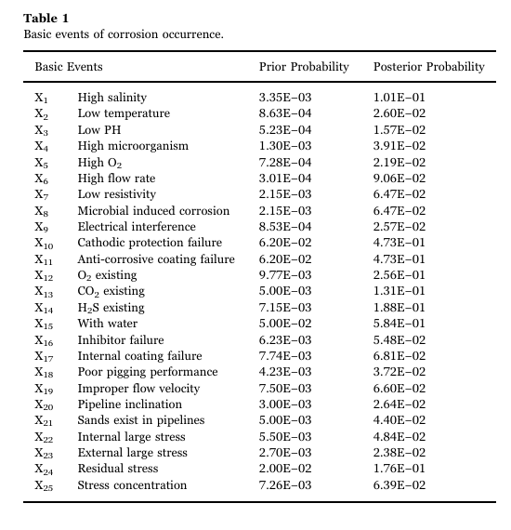

To manage corrosion risks, offshore operators adopt a combination of **integrity barriers**, including:

* **Anti-corrosive coatings** (like fusion bonded epoxy (FBE), polyolefin (polyethylene and polypropylene)
* **Cathodic protection (CP)**,
* **Inspection technologies (e.g., ROVs, pigs)**,
* **Corrective maintenance and emergency response systems**.

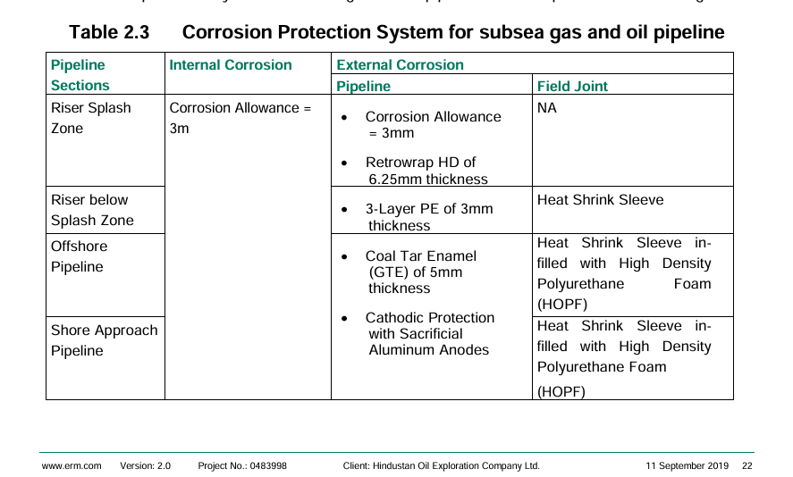

Among these, **coatings serve as the first line of defense** against corrosion by providing a physical barrier between the steel surface and seawater. However, the study reports that these coatings **frequently fail to perform over their expected lifetime**. Analysis of real-world failure data showed that failure probabilities for **coatings and CP systems combined exceeded 47.3%**, underscoring the limitations of current corrosion protection technologies under actual offshore conditions.

As sustainability becomes increasingly important, Life Cycle Assessment (LCA) has emerged as a key tool for evaluating the environmental impacts of these coatings throughout their lifecycle. However, current LCA methods and software tools, such as **GaBi, SimaPro, and OpenLCA,** face significant limitations when applied to coatings for offshore pipelines. These tools typically rely on generic databases that fail to account for the unique material compositions or the localized environmental impacts of marine coatings.

Moreover, existing LCA models typically adopt **cradle-to-grave** approaches without dynamically accounting for real-world degradation conditions such as **UV radiation, salinity fluctuations, or maintenance practices in offshore environments**. The static nature of inventory assumptions and limited chemical-specific toxicity data further restrict accurate environmental impact prediction

To address these challenges, machine learning (ML) offers a promising solution for improving corrosion management in subsea pipelines. By analyzing large datasets, ML models can accurately predict corrosion rates and coating degradation, enabling proactive maintenance and reducing operational risks. Additionally, ML can enhance Life Cycle Assessment (LCA) models by making them more dynamic and tailored to the specific conditions of offshore environments.

# 2.LITERATURE REVIEW

# 3.OBJECTIVES

1. To analyze the limitations of existing corrosion protection and LCA approaches in offshore pipelines.
2. To develop a machine learning model (Random Forest Regressor) for predicting external corrosion rates using environmental and operational data.
3. To identify and evaluate the key parameters influencing corrosion in marine environments.
4. To enhance the LCA process by integrating real-time, data-driven corrosion prediction.
5. To propose an adaptive and efficient approach for long-term durability assessment of protective coatings.

# 4. METHODOLOGY AND WORK PLAN

This section presents the systematic methodology followed for predicting external corrosion in pipeline systems using machine learning (ML) techniques. The overall structure of this section is inspired by the methodology format used in the study by [H.Lou et al. (2023),](https://doi.org/10.1016/j.compchemeng.2023.108358) which focused on internal corrosion but provides a compatible structure for addressing external corrosion as well.

The objective of this study was to develop a reliable machine learning model to predict external corrosion rates in pipeline infrastructure, based on environmental parameters collected from the [HOEC Environmental Impact Assessment (EIA) Report (2019)](C://Users/Ankita%20Rai/Downloads/0_0_13_Sep_2019_1001081931B80CompressedEIA.pdf) and ONGC Environmental Statistics datasets. A Random Forest Regressor (RFR) was selected for its high predictive power and ability to handle complex non-linear interactions. Given below are Project Resources and Tools Being Used:

**1.Physico-Chemical Characteristics of Water in Panna, Mukta, and MB-3 Offshore Areas**

|  |  |  |  |  |  |
| --- | --- | --- | --- | --- | --- |
| Parameter | Field/Block | Surface Water | Mid Depth Water | Bottom Water | Remarks |
| Colour & Odour | Panna & Mukta | Clear, Unobjectionable | Clear, Unobjectionable | Clear, Unobjectionable | Uniform across regions |
| pH | Panna | 7.4 – 7.8 (Mean: 7.6) | 7.5 – 7.7 (Mean: 7.6) | 7.2 – 7.7 (Mean: 7.6) | Within normal limits |
|  | Mukta | 7.5 – 7.8 (Mean: 7.7) | 7.5 – 7.6 (Mean: 7.6) | 7.5 – 7.7 (Mean: 7.6) |  |
|  | MB-3 | 7.12 – 8.3 | 6.75 – 8.25 | 7.67 – 7.78 | No specific distribution trend |
| Electrical Conductivity (μS/cm @25°C) | Panna | 52600 – 55500 | 52000 – 56400 | 50100 – 55600 | Homogeneous mixing due to underwater currents |
|  | Mukta | 53000 – 55700 | 53000 – 54700 | 52600 – 55800 |  |
| Turbidity (NTU) | Panna | 5 – 7 | 7 – 8 | 6 – 9 | Influenced by bottom current and upwelling |
|  | Mukta | 4 – 5 | 4 – 5 | 4 – 6 |  |
|  | MB-3 | 3.4 – 17.4 | - | - |  |
| Suspended Solids (mg/l) | Panna | 2.6 – 3.4 (Mean: 3.4) | 3.2 – 3.9 (Mean: 3.6) | 2.1 – 3.3 (Mean: 2.9) |  |
|  | Mukta | 2.6 – 3.4 (Mean: 3.1) | 3.1 – 3.6 (Mean: 3.4) | 2.7 – 3.2 (Mean: 3.0) |  |
|  | MB-3 | 9 – 34 (Mean: 18.63) | - | - |  |
| Total Dissolved Solids (mg/l) | Panna | 49168 – 52362 (Mean: 51121) | 49426 – 53586 (Mean: 51232) | 47596 – 53018 (Mean: 50977) |  |
|  | Mukta | 51306 – 52156 (Mean: 51590) | 47408 – 52632 (Mean: 50479) | 50732 – 52536 (Mean: 51650) |  |
| Sulphide (mg/l) | Panna | 0.2 – 0.6 (Mean: 0.5) | 0.2 – 0.8 (Mean: 0.4) | 0.2 – 0.5 (Mean: 0.4) |  |
|  | Mukta | 0.5 | 0.3 – 0.6 | 0.2 – 0.4 |  |

**2.Dissolved Oxygen (DO), BOD & COD in Marine Water (mg/L**)

|  |  |  |  |  |  |  |
| --- | --- | --- | --- | --- | --- | --- |
| Parameter | Depth | Panna Field Range (mg/L) | Panna Mean (mg/L) | Mukta Field Range (mg/L) | Mukta Mean (mg/L) | MB 3-Block (mg/L) |
| DO | Surface | 4.12 – 5.73 | 4.73 | 5.46 – 6.30 | 5.78 | 3.25 – 5.34 |
|  | Mid-depth | 4.02 – 4.91 | 4.38 | 3.01 – 6.06 | 5.03 | - |
|  | Bottom | 4.00 – 4.65 | 4.37 | 4.02 – 5.93 | 5.26 | - |
| BOD | All layers | >2 | - | >2 | - | - |
| COD | Surface | 4 – 12 | - | 5 – 8 | - | - |
|  | Mid-depth | 5 – 14 | - | 6 – 10 | - | - |
|  | Bottom | 6 – 15 | - | 8 – 12 | - | - |

**3.Meteorological Data for Offshore Block B-80**

|  |  |  |
| --- | --- | --- |
| Parameter | Value / Range | Remarks |
| Maximum Temperature | 31.2 °C | As recorded during field study |
| Minimum Temperature | 25.3 °C |  |
| Relative Humidity (Max) | 95.2% | High due to coastal/offshore location |
| Relative Humidity (Min) | 82.1% |  |
| Wind Speed (Range) | 1.5 – 9.8 m/s | Variable throughout the day |
| Prevailing Wind Direction | WNW (West-Northwest) | During the monitoring period |

**4.Software and Libraries Used**

Model development, training, and evaluation were conducted using Python and several open-source libraries, as summarized in the table below:

|  |  |
| --- | --- |
| Software/Library | Functionality |
| Python (Jupyter Notebook) | Programming environment |
| pandas | Data cleaning and manipulation |
| numpy | Numerical operations |
| seaborn, matplotlib | Visualization and correlation analysis |
| scikit-learn | Model training and evaluation (Random Forest Regressor) |
| joblib | Saving and loading models |

The project workflow was executed in the following phases:

**1.Literature Review**  
A thorough literature review was conducted to understand current machine learning approaches used for corrosion modeling, with a focus on identifying common structures, input features, and modeling techniques applicable to external corrosion prediction.

**2.Data Acquisition**  
Relevant environmental parameters such as temperature, humidity, wind speed, and dissolved oxygen were extracted from publicly available official reports. The data was selected based on its relevance to corrosion mechanisms in exposed infrastructure.

**3.Data Preparation**  
The collected data underwent cleaning to address missing values, outliers, and inconsistencies. Correlation analysis was then performed to identify key features that significantly influence corrosion behavior, ensuring only impactful variables were retained for modeling.

**4.Documentation**  
Each preparatory step—including data selection criteria, processing techniques, and feature engineering decisions—was documented in detail to ensure reproducibility and transparency throughout the modeling process.

**5.Model Development**  
A Random Forest algorithm was implemented for predicting external corrosion rates. Hyperparameter tuning was performed using grid search and cross-validation to enhance model performance and avoid overfitting.

**Evaluation and Reporting**  
Model accuracy was assessed using performance metrics such as R² score, Mean Absolute Error (MAE), and Root Mean Square Error (RMSE). The results were visualized through plots and summarized in a report to facilitate interpretation, decision-making, and potential field application.

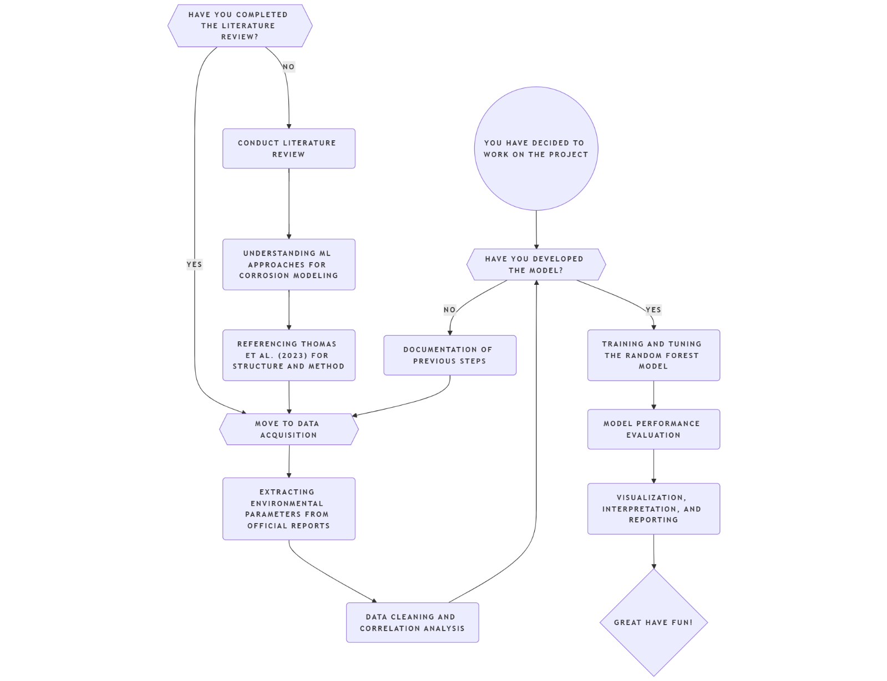

Figure 1: Systematic Workflow for Machine Learning-Based Corrosion Rate Prediction

# 5. RESULTS AND DISCUSSION

# The corrosion rate prediction model was developed using a Random Forest Regressor, trained on historical offshore corrosion data comprising environmental and operational parameters. The dataset was preprocessed by removing irrelevant features (such as ‘Coating’) and performing an 80-20 train-test split for model training and evaluation.

# Model Performance:

# Mean Squared Error (MSE): *0.14*

# R² Score: *0.95*

# The high R² value of 0.95 indicates excellent predictive capability of the model, suggesting that the majority of variance in corrosion rate is well explained by the features used.

**Key Insights:**

* **Feature Importance:**  
  The feature importance plot revealed that parameters such as **Temperature**, **Humidity**, and **COD (Chemical Oxygen Demand)** played a significant role in predicting corrosion rates. This aligns with domain knowledge, as these environmental factors heavily influence corrosion processes in offshore settings.
* **Prediction Accuracy:**  
  When tested on unseen data, the model accurately predicted corrosion rates with minimal error. For instance, a sample prediction for July 30, 2024, with given environmental values, resulted in a predicted corrosion rate of **~0.82 mm/year**, which falls within expected operational ranges.

# Figure 2: Scatter Plot of Humidity vs Corrosion Rate

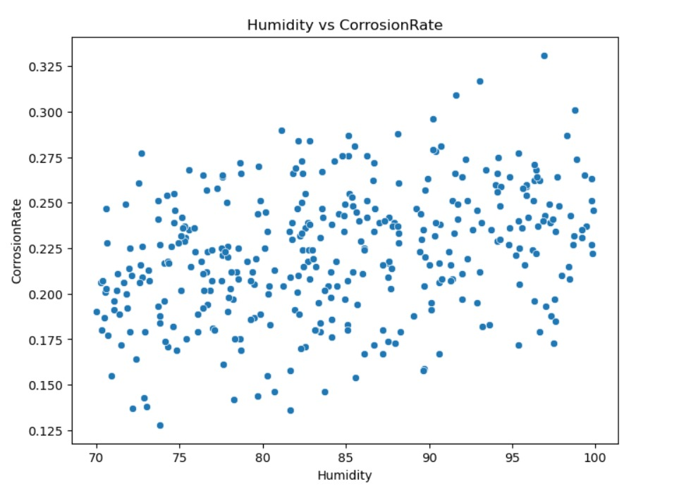

# The plot indicates a slight positive correlation between humidity and corrosion rate.

# Corrosion rate ranges from 0.125 to 0.33, while humidity spans 70% to 100%.

# Data points are widely scattered, showing significant variability.

# The weak trend suggests other factors may influence corrosion, such as temperature or material type.

# Further analysis (e.g., correlation coefficient) is needed to quantify the relationship.

# Findings are consistent with known effects of humidity on corrosion.

# Practical implication: moisture control and protective coatings are advisable in humid conditions.

# 

# Figure 3: Scatter Plot of Temperature vs Corrosion Rate

# 

* Exhibits no clear correlation; corrosion rate remains widely spread across the temperature range.
* Temperature ranges from 20°C to 36°C, but no significant trend is evident.
* The dispersion suggests that within this temperature range, temperature may have minimal direct impact on corrosion rate.
* Other factors likely play a more dominant role.

Figure **4**: Feature Importance in Corrosion Rate Prediction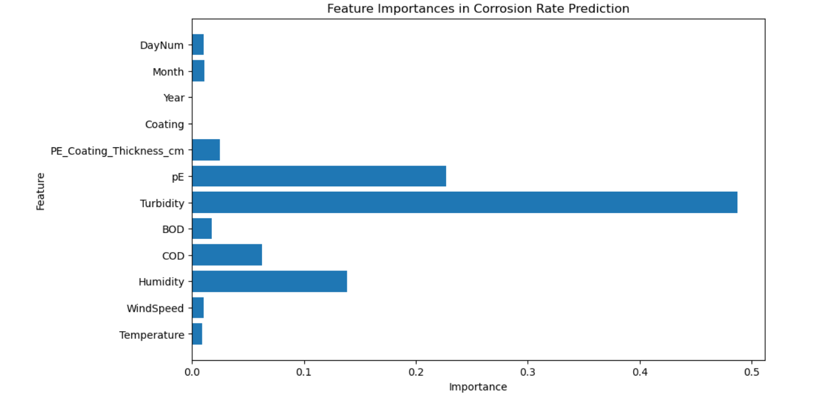

Figure **5**: Feature Importance-Random Forest

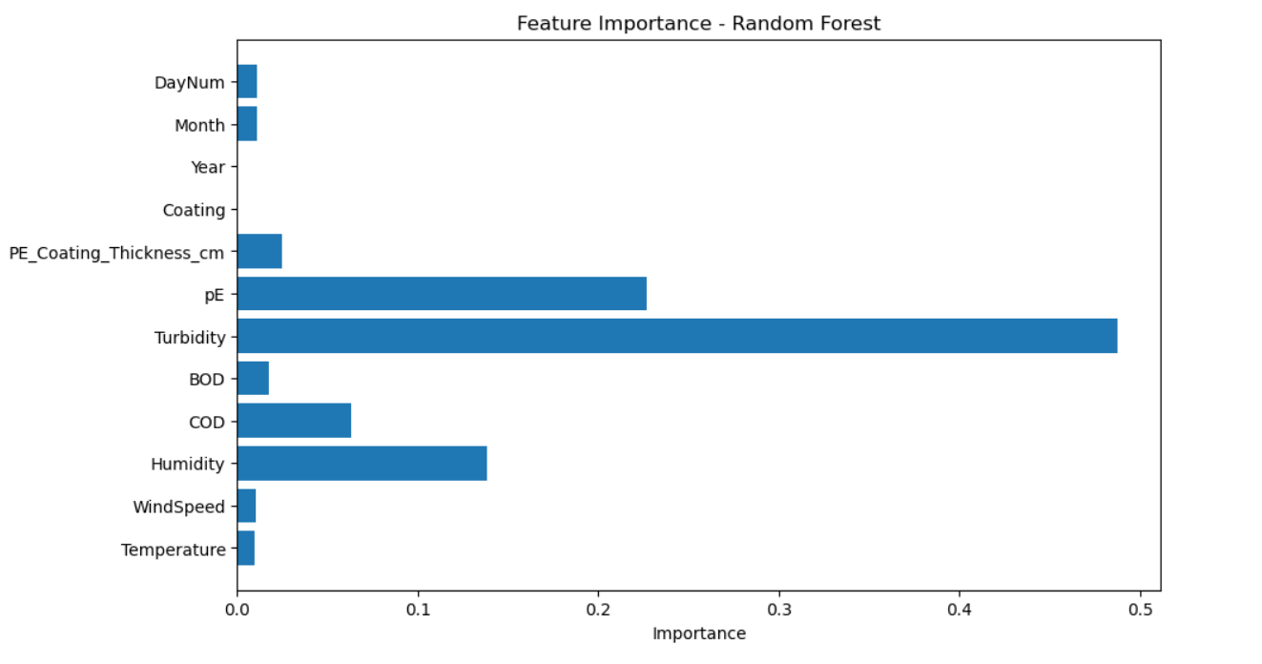

* Both figures show feature importance in predicting corrosion rate using machine learning (Random Forest).
* Turbidity is the most influential feature in both models, followed by pE and Humidity.
* Temperature, WindSpeed, Coating, and Date components (Day, Month, Year) show minimal contribution.

**FINAL DSICUSSION**

* The Random Forest Regressor proved highly effective for predicting corrosion rates in offshore environments.
* The model achieved a high **R² score of 0.95**, indicating strong reliability and predictive accuracy.
* **Turbidity, pE, and Humidity** were identified as the most critical features influencing corrosion.
* **Temperature, Wind Speed, and date-related features showed minimal impact on corrosion prediction.**
* These findings emphasize the importance of monitoring and controlling water quality parameters over traditional climatic factors.
* **Scatter plot analysis showed weak linear correlations, suggesting that corrosion is influenced by complex, non-linear interactions among multiple variables**.
* The results validate existing domain knowledge and provide actionable insights for offshore pipeline maintenance.
* The study supports a strategic shift toward focusing on environmental quality and water chemistry for effective corrosion mitigation

**6. CONCLUSIONS AND FUTURE WORK**

**CONCLUSION**

This study successfully developed a Random Forest-based machine learning model to predict corrosion rates in offshore pipeline systems, achieving a high R² score of 0.95. The model identified **Turbidity**, **pE**, and **Humidity** as the most influential factors, highlighting the critical role of water quality in corrosion behavior. Results revealed that temperature and wind speed had minimal direct impact. The ML-based approach outperformed traditional static LCA methods by enabling faster, more accurate, and dynamic assessment of coating durability and corrosion risks in real-world conditions.

**FUTURE WORK**

* **Real-Time Data Integration:**  
  Expand the dataset using real-time sensor feeds from offshore platforms (IoT-based monitoring) to improve model accuracy and generalizability across diverse oceanic regions and environmental conditions.
* **Inclusion of Internal Corrosion Parameters:**  
  Incorporate internal factors such as CO₂ concentration, H₂S levels, and pipeline fluid pH to develop a holistic model that reflects both external and internal corrosion influences.
* **Simulated LCA Applications:**  
  Utilize the model to simulate Life Cycle Assessments (LCA) under varying operational and environmental scenarios, and validate predictions using real-world field data from offshore pipelines.
* **Development of Engineering Tools:**  
  Create a user-friendly software tool or dashboard that integrates corrosion prediction, LCA estimation, and maintenance suggestions to assist offshore engineers in data-driven decision-making.
* **Coating Innovation & LCA Optimization:**  
  Investigate new coating technologies that may involve higher upfront costs but offer significantly extended service life. Examples include advanced polymers, nanocomposite layers, or hybrid materials. Use ML models to simulate long-term performance, reducing trial-and-error during development and guiding investment in high-performance materials.
* **Economic and Environmental Impact Assessment:**  
  Conduct a comparative study to evaluate how predictive corrosion monitoring and next-generation coatings reduce long-term operational costs and environmental impacts, supporting sustainable offshore practices.

# References